**Supplementary Material**

**Functional and structural brain changes in anti-NMDAR encephalitis**

Carsten Finke, Ute A. Kopp, Michael Scheel, Luisa-Maria Pech, Carina Soemmer, Jeremias Schlichting, Frank Leypoldt, Alexander U. Brandt, Jens Wuerfel, Christian Probst, Christoph J Ploner, Harald Prüss#, Friedemann Paul#

**MRI data acquisition**

Whole-brain MRI data were acquired on a Siemens Magnetom Tim Trio 3T scanner equipped with a 12-channel phased-array head coil. First, high-resolution 3D T1-weighted MRI scans were collected using a magnetization-prepared rapid gradient echo (MPRAGE) sequence (TR = 1900 ms, TE = 2.55 ms, TI = 900 ms, flip angle = 9°, FOV = 240 x 240 mm², matrix size = 240 x 240, 176 slices, slice thickness = 1 mm). Resting state BOLD fMRI data were acquired for each subject using an echo-planar imaging sequence (TR = 2250 ms, TE = 30 ms, flip angle = 90°, FOV = 218 x 218 mm², matrix size = 64 x 64, voxel size = 3.4 x 3.4 x 3.4 mm³, 37 axial slices aligned to the bicommissural plane, slice thickness = 3.4 mm, interslice gap 0.6 mm, 260 volumes, acquisition time 9 min 51 s). Participants were instructed to lie still with their eyes closed while remaining awake. Diffusion tensor imaging was performed using a single-shot echo-planar imaging sequence (TR = 7500 ms, TE = 86 ms, FOV = 240 x 240 mm², voxel size = 2.5 x 2.5 x 2.3 mm³, 61 slices, 64 diffusion directions, *b* value = 1000 s/mm²). Finally, a 3D T2-weighted sequence (TR = 5000 ms, TE = 502 ms, FOV = 256 x 256 mm², matrix size = 256 x 256, 176 slices, slice thickness = 1 mm) and a 3D T2-weighted fluid-attenuated inversion recovery sequence (TR = 5000 ms, TE = 388 ms, TI = 1800 ms, FOV = 250 x 250 mm², matrix size = 250 x 250, 176 slices, slice thickness = 1 mm) were acquired.

**Analysis of resting state functional connectivity**

Individual preprocessing included discarding the first four volumes to ensure magnetisation equilibrium, brain extraction, motion correction, high-pass filtering with a frequency cut-off at 100 s, spatial smoothing using a Gaussian kernel of full-width half maximum (FWHM) of 6 mm and affine registration to the MNI 152 standard template. Global signal regression was not performed. Absolute head motion was below 0.8 mm for all 48 subjects and did not differ between patients and controls (p > 0.15). Resting state networks common to all subjects were identified using temporal-concatenation ICA as implemented in Multivariate Exploratory Linear Optimized Decomposition into Independent Components (MELODIC, part of FSL).1

The between-subject analysis was carried out using the dual regression approach that allows for voxel-wise comparison of resting functional connectivity.2 Dual regression proceeds in two steps and identifies subject-specific time courses and associated spatial maps. First, group-ICA spatial maps are used in a linear model fit against the individual fMRI datasets (spatial regression). This step results in matrices describing the temporal dynamics of the corresponding resting state network for each of the 48 subjects. Second, these time-course matrices are normalised by their variance and used in a linear model fit against the individual fMRI datasets (temporal regression). This step results in subject-specific spatial maps of the anterior and posterior DMN. These maps are collected across subjects in two separate 4D files (with subjects being the fourth dimension). Finally, these 4D files are tested voxel-wise for statistically significant differences between groups using non-parametric permutation testing (5000 permutations) with threshold-free cluster enhancement (TFCE) implemented in the FSL tool randomise (p < 0.05, FWE-corrected).3,4 Analysis was constrained to the cortex by a group mean mask of the averaged grey matter segmentations obtained from each subject’s MPRAGE.

**White matter - Diffusion tensor imaging**

Preprocessing of the DTI data included brain extraction and correction for eddy current distortions. The FSL tool Tract-Based Spatial Statistics (TBSS) was used for voxel-based analysis.5 The individual FA maps were non-linearly registered to group-specific templates generated from all subjects and narrowed to a so-called FA skeleton that represents the center of all tracts common to the group. Subsequently in each individual subject, the neighbourhood orthogonal to the skeleton is searched for the highest FA value and then assigned back to the skeleton. The registration warp fields and projection information derived from the FA analysis are then applied to the MD, AD, and RD maps of each subject ensuring an exact spatial correspondence of the different parameters. The resulting data are then fed into a voxel-based cross-subject statistics using non-parametric permutation testing (5000 permutations) with TFCE implemented in the FSL tool randomise (p < 0.05, FWE-corrected).3,4 To facilitate visualization, regions showing significant changes of FA, MD and/or RD are thickened using the tbss_fill script implemented in FSL.

**Table S1.** Regression coefficients of dual regression analysis for control regions (extracted from 12-mm-diameter spheres centered on previously published foci; frontal eye fields6, dorsolateral prefrontal cortex7) showed similar values for patients and controls.

|  |  |  |  |  |
| --- | --- | --- | --- | --- |
|  |  | **MNI coordinates** | **Regression coefficient patients**  (mean ± sem) | **Regression coefficient controls**  (mean ± sem) |
| **Frontal eye field** | Left | - 25, -13, 50 | 4.7 ± 1.8 | 4.0 ± 1.7 |
|  | Right | 25, -13, 50 | 3.6 ± 1.4 | 3.0 ± 1.9 |
| **Dorsolateral prefrontal cortex** | Left | 40, 46, 22 | 6.8 ± 1.7 | 5.4 ± 3.2 |
|  | Right | -40, 46, 22 | 5.4 ± 2.4 | 5.6 ± 2.9 |

**Figure S1.** Left and right hippocampal regression coefficients from dual regression analysis that indicate the hippocampal-aDMN connectivity are shown for controls and for patients with low, medium and good memory performance in the RAVLT (RAVLT sum scores < 55, 55-65, and > 65, respectively) for illustrational purposes. RAVLT sum scores are significantly correlated with left (r = 0.64, p = 0.001) and right (r = 0.6, p = 0.001) hippocampal regression coefficients such that patients with reduced hippocampal-aDMN connectivity exhibit worse memory performance.

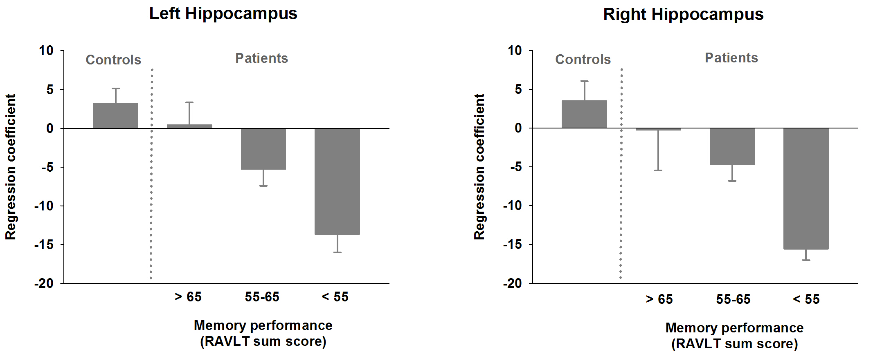

**Figure S2.** Whole brain fractional anisotropy (FA) is shown separately for controls and for patients with modified Rankin scale (mRS) scores of 0, 1 and 2-3 (patients with mRS scores of 2 and 3 are analyzed together due to small group sizes). mRS scores are significantly correlated with whole brain FA (r = -0.45, p < 0.001) with more severely affected patients (i.e. patients with higher mRS scores) showing more extended white matter damage (i.e. reduced whole brain FA).

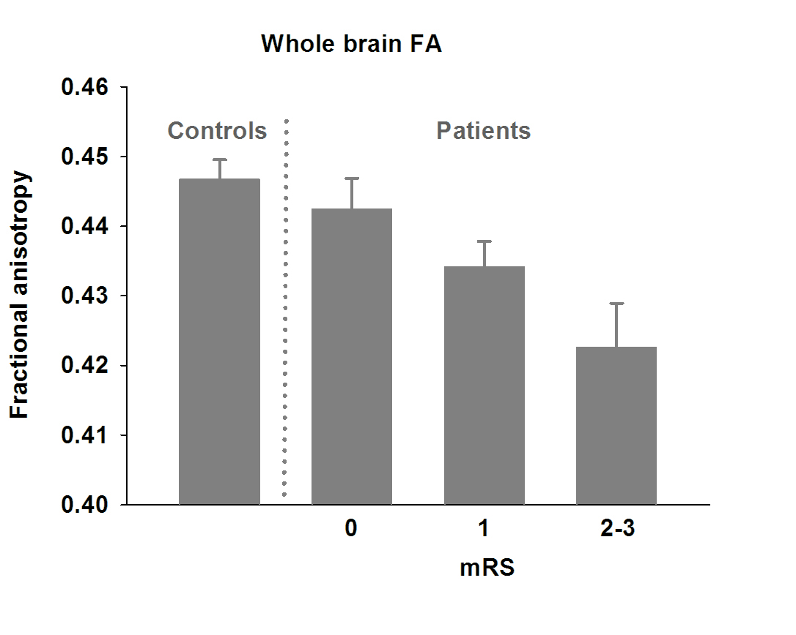

**Figure S3.** Following the analysis of the default mode network, the auditory network (A), the sensorimotor network (B), and the primary visual network (C) were additionally identified using ICA. Dual regression analysis did not reveal significant differences between patients and controls for these networks.

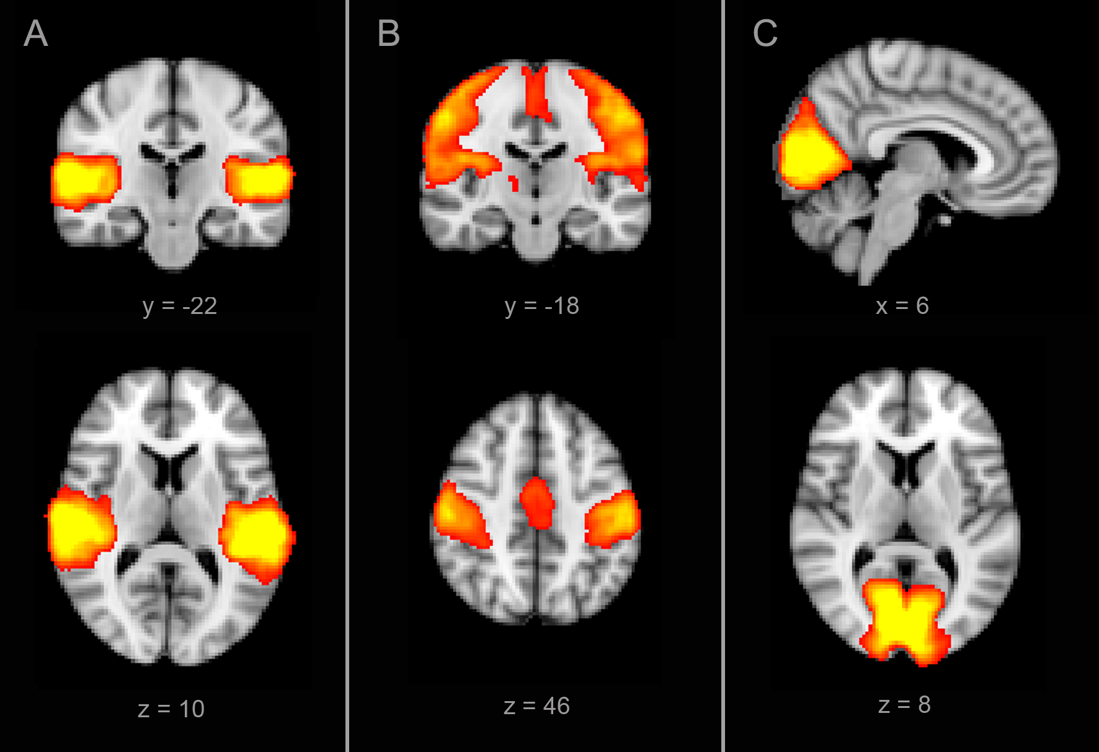

**References**

1 Beckmann CF, DeLuca M, Devlin JT, Smith SM. Investigations into resting-state connectivity using independent component analysis. *Philosophical transactions of the Royal Society of London Series B, Biological sciences* 2005; **360**: 1001–13.

2 Filippini N, MacIntosh BJ, Hough MG, *et al.* Distinct patterns of brain activity in young carriers of the APOE-epsilon4 allele. *Proceedings of the National Academy of Sciences of the United States of America* 2009; **106**: 7209–14.

3 Nichols TE, Holmes AP. Nonparametric permutation tests for functional neuroimaging: a primer with examples. *Human brain mapping* 2002; **15**: 1–25.

4 Smith SM, Nichols TE. Threshold-free cluster enhancement: addressing problems of smoothing, threshold dependence and localisation in cluster inference. *NeuroImage* 2009; **44**: 83–98.

5 Smith SM, Jenkinson M, Johansen-Berg H, *et al.* Tract-based spatial statistics: voxelwise analysis of multi-subject diffusion data. *NeuroImage* 2006; **31**: 1487–505.

6 Corbetta M, Kincade JM, Shulman GL. Neural systems for visual orienting and their relationships to spatial working memory. *J Cogn Neurosci* 2002; **14:** 508–23.

7 Sakai K, Rowe JB, Passingham RE. Active maintenance in prefrontal area 46 creates distractor-resistant memory. *Nat Neurosci* 2002; **5:** 479–84.